Fellowship CommUnity Group
Discussion Guide for Leaders

Series: Ruin, Rebuild, Renew
Sermon: External Opposition Begins
2-24-19

- Getting To Know Each Other Opening Question: What do you like/enjoy most about winter?

- Opening Prayer. (Either leader, host home or someone who is willing to pray out loud)

(Notes from message for reference only – use only as needed)
**Use Sermon notes bulletin insert

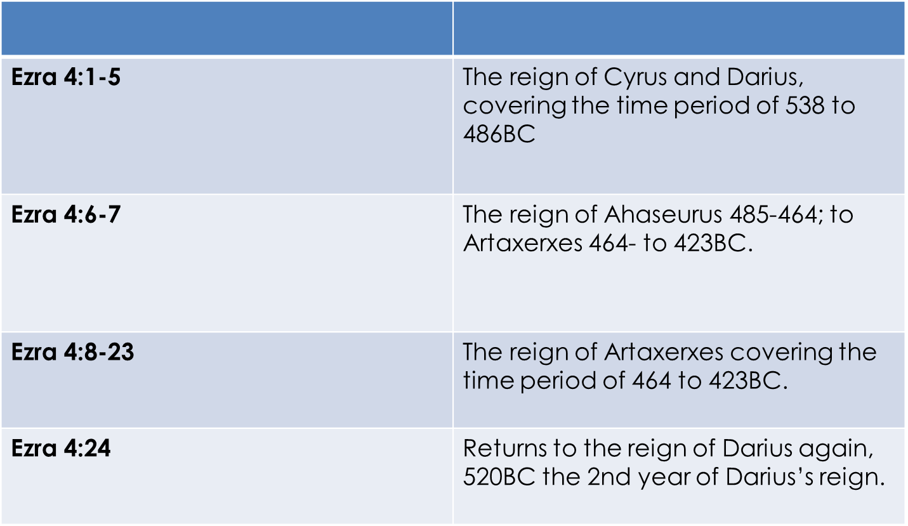

Why does Ezra write this passage in this way?
1) Ezra is pointing out that the returnees are united on one side and all opposition from various periods of time are on the other. 2) Ezra is pointing out that all returnees are one united group even though multiple groups came back at different times. 3) Ezra is pointing out that opposition in his generation will be defeated just as opposition from earlier generations was defeated.
Strategies of Opposition
1) The opposition targets the leaders first.
>>We must be unrelentingly inclusive of all people while remaining unapologetically exclusive in our gospel.
2) The opposition targets the people next.
3) The opposition uses the governing authorities.
Tactics of Opposition
a) Exaggeration b) Find the Hot Issue c) Misrepresent Motives d) Selective with Facts e) Influence the Outcome
Ezra’s Main Point: The opposition worked and it can work against us too if we allow it to.

What else can NT believers learn about opposition?
1) Only Holy Spirit indwelt believers can be gospel witnesses to the world – this is our battle to fight!
2) Believers on mission should expect opposition. 3) Believers must battle opposition with prayer.
4) Believers are counted as Christ when facing the enemy’s opposition.
Into The Text (15 Minutes) (Leaders: This time is not meant to be application yet, this is time in the Word, before we seek to apply truth, we need to understand the truth. The section after this one will focus on application.)

- Ask someone to read Ezra 4:1-3. Ask: Why does Ezra refer to the group of people offering to help as ‘adversaries’? Why did Zerubbabel refuse the help of those asking to help in V1? Why did these ‘adversaries’ want to help if they were already known as ‘adversaries’?

- Ask someone to read Ezra 4:4-5. Ask: How did the adversaries cause the people of God to stop the rebuilding? What entered into the hearts of the people of God? Considering what we know about these people from the previous chapters, how could this happen?

- (Remind the group that Ezra 4:6-23 refers to a time about 15 years after Ezra 4:1-5) Ask someone to read Ezra 4:6-10. Ask: Who does Rehum and Shimshai claim to represent in this passage? How likely is it that they actually represented all of these people?

- Ask someone to read Ezra 4:11-16. Ask: Why did they refer to the city of Jerusalem as wicked? Why did they focus on the king’s revenue? How much exaggeration and false claims do you see in this letter? What does this tell us about the opposition the people of God were facing?

- Ask someone to read Ezra 4:17-23. Ask: Is the king’s response a surprise? Why or why not? How quickly did Rehum and Shimshai respond when they got Artaxerxes letter? Ask someone to read Ezra 4:24. Ask: Why does Ezra want us to know that the rebuilding stopped?

Application & Discussion (15-20 Minutes)
- Say: Let’s move to application and discussion. Ask: Is there a time that Christians should compromise to work alongside others? When should we refuse? What determines our response?

- What are some ways secular agencies claim to help the church in its gospel mission? Is our society becoming more or less tolerant to the belief that salvation only comes through Jesus Christ? Is that message seen as unloving and non-inclusive to some people? Why?

- Ask: How easily do you become discouraged? How does discouragement typically affect you?
- Ask: Should we expect opposition to the gospel and to believers who share the gospel? How can we prevent opposition from causing us to give up on our mission of gospel witness?
- Ask: Are there ways that enemies are opposing your attempts to advance God’s kingdom now? If so, how?

Closing Prayer Time: (10-12 Minutes) (Leader Say:) Let’s close with a time of prayer. Ask the Lord to help us remain faithful to him no matter the opposition. Pray for those in your group who are experiencing opposition in their life. (Ask someone to open, let people pray as they feel led, and then leader closes.)

